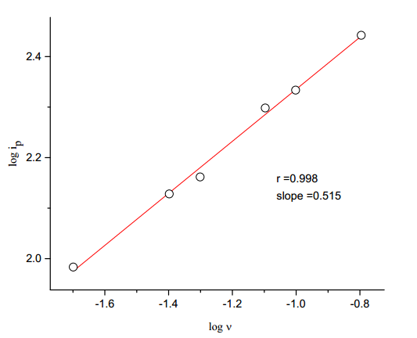

Fig. (3). Plot of logarithm of peak current on logarithm of scan rate for the first peak.

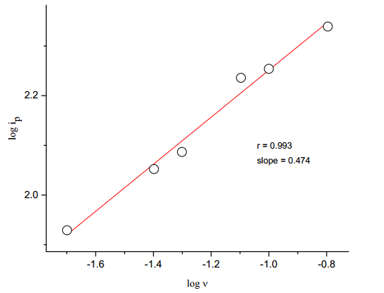

Fig. (4). Plot of logarithm of peak current on logarithm of scan rate for the second peak.